REU Report for Jonatan Gonzalez

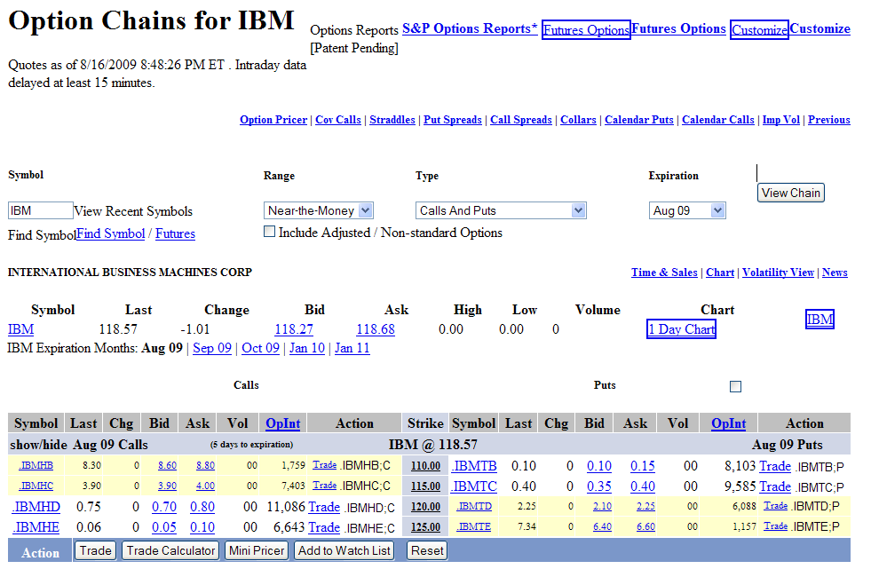
Jonatan joined Financial Derivatives in Grid Computing project in the middle of September 2009. Vysakh, a finance expert of the project introduced Jonatan to the overall concept, significance and application potential of the project. He explained the idea behind trading call and put option derivatives and how, when and why they are exercised. Then, Melita presented the overall idea of the project scope and how it relates to the actual broker. A Broker needs to have a range of call and put option values available to make his decision. One of the real time systems is shown in the Figure 1.

Figure 1. Example of a Trading Window for IBM Stock.

This window shows that at any particular time, i.e at every stock price change, what the Broker would like to see, for a given Exercise Price, are price options for puts and calls within determined Strike Price range. To better understand how the stock price is changing with respect to time, price, market volatility, and interest rates Brokers would like to obtain not only the price prediction, but change predictions as well. In Finance these variables are called Greeks. To accommodate different hedge preferences options are divided into American, European, and Asian. In the European the stock is exercised only at a specific time T. In the American he was explained that the stock can be exercised at any time between the start and T. The Asian is similar to the American with the exception that the exercise price is the average of the prices. To model a diverse combination of factors, such as unpredictability and volatility of the market, finance principles, as well as the common sense logic, Jonatan was introduced to four methods for finding information about the stocks. Black Scholes calculations are closed form solutions that do not always exist. The other methods, Monte Carlo, Binomial and Finite Difference are all well understood numerical methods that approximate theoretical models. In practice, most financial institutions do not rely on one method only, but take the average as the final option value. The volatility would be calculated with historical data or the Newton method.
To obtain the time complexity of the problem, for one stock only, once per second, the Broker would like to get, 15 option values and 75 related Greek values, for both puts and calls, by every method/model available. (In this project number of available methods is 4).
Currently the Binomial method has been implemented completely and is ready for timing. The timing data will provide basis for parallelism via threading and in Grid. Jonatan has edited the program in order to time the binomial option values and the Greek for both Call and Put options. The time returned grows quadratically with number of time periods considered, hence justifying the need for using the grid system. In the table bellow is the summary of the most important time periods a Broker would like to obtain.

nTime | Time*1 | Time*2
480 | .93 seconds | 3.83 seconds
480*5 | 23.9 seconds | 129 seconds
480*5*4 | 705.89 seconds | 760 seconds
480*5*12 | 210.485 seconds | 1302.37 seconds

Figure 2. Excert of Binomial Method Timing

In Figure 2. nTime is time granularity at which Binomial Method option price and Greeks were obtained. For example, 480 represents a data per day, at granularity 60 minutes times eight hours. By multiplying it by five it turns into a week, by four a month, and by 12 into a quarter (3 months). nTime times 1 doesn’t do anything, but by multiplying the nTime by two it changes the time granularity to every half a minute.
Apart from learning about the project and obtaining timing results, Jonatan has helped in experimenting and understanding what tools would be most beneficial.
The colleagues from China made mention of using Boost for MPI. Melita had mentioned that Boost is very popular in industry and asked Jonatan to look into it. He found that Boost included ways to use MPI easily. Boost also allows for better construction of arrays and N-dimensional arrays, but he found it difficult to install. Also the many benefits of using Boost do not apply to this project.
On Thursday nights there would be a meeting with china via Skype. Although everyone had microphones and could speak there would be situations where typing was easier in order to avoid confusion. The time differences made it difficult to coordinate appropriate times for meeting with China. The difference is 13hours to be exact.
As a semi-schedule for the project there are 5 main milestones. Firstly the Monte Carlo, Binomial, Black Scholes, and Finite Difference Equation methods must be implemented. After which the program needs to output its values to an excel file. The easiest way to do this is to create a CSV file, comma-separated values. Excel can read and save files in this format. The next point in the project will be to parallelize the methods using MPI for running on grid. This is followed by actually running the program on Grid. If there is time left over and the results are correct then the project could be run on a cloud computing network.

